A Retrieval-Augmented Question Answering System for Software Engineering Course Documents
Lukhanyo Floris Kalashe
2023575000@ufs4life.ac.za
Department Of Computer Science and Informatics
University of The Free State
South Africa
Abstract
This study proposes a Retrieval-Augmented Question Answering (RAG) system designed specifically for a third-year Software Engineering module. While university students accumulate vast amounts of lecture material, traditional keyword search is inefficient, and standard Large Language Models (LLMs) are prone to hallucinating academic definitions. To address this, a local RAG pipeline was developed over a 398-page corpus of course slides. The system compares sparse retrieval (TF-IDF) with dense semantic retrieval (FAISS and all-MiniLM-L6-v2) before passing grounded context to the GPT-4o-mini generation model. Empirical data exploration justified a page-level chunking strategy due to a low mean word count (49 words per slide). Results from a dual-evaluation framework revealed that while baseline dense retrieval achieved high factual grounding (92.9% manual score), it suffered from a strict refusal penalty on fragmented queries (0.351 cosine similarity to ground truth). The implementation of a Hybrid Reciprocal Rank Fusion (RRF) pipeline, paired with a 0.25 confidence threshold, resolved these blind spots, increasing the mean answer similarity to 0.786 (+0.434) and ensuring zero hallucination on out-of-scope queries.

Keywords: Retrieval-Augmented Generation, Large Language Models, Academic Documents, Question Answering
- Introduction
University students enrolled in Computer Science programmes typically accumulate vast amounts of lecture slides, study notes, and supplementary materials. While these resources are critical for academic success, manually searching through them to find specific explanations or definitions is often highly time-consuming.

The primary gap this project addresses is the dual inefficiency of current search paradigms in academic contexts: traditional keyword-based searches fail to capture the underlying semantic meaning of a student's paraphrased query, whereas employing modern Large Language Models (LLMs) without grounding introduces an unacceptable risk of hallucination, particularly with module-specific terminology [1, 5].

The aim of this project is to develop and evaluate a tailored Retrieval-Augmented Generation (RAG) system that allows students to ask natural-language questions and receive factually grounded answers with exact source citations from their lecture materials.

This paper makes four specific contributions:

- The development of a localised RAG architecture built specifically for highly formatted academic course documents.
- An empirical comparison between sparse retrieval (TF-IDF) and dense semantic retrieval (FAISS) to identify the optimal baseline strategy.
- The implementation of a Hybrid Reciprocal Rank Fusion (RRF) pipeline with a confidence threshold to dynamically filter out-of-scope questions.
- A dual-evaluation framework utilising both human-expert rubric scoring and automated ground-truth cosine similarity metrics.

- Background / Related Research
Retrieval-Augmented Generation (RAG) mitigates the hallucination problem inherent in LLMs by forcing the model to synthesise answers exclusively from dynamically retrieved, verified documents [5]. Recent applications of RAG in academic and scientific domains have demonstrated significant improvements in factual accuracy. For instance, Auer et al. [2] highlight how scientific question-answering benchmarks require deep semantic understanding rather than superficial keyword matching.

Similarly, Alat et al. [1] demonstrated the viability of academic question-answer systems using local embedding models and FAISS indexes, proving that expensive commercial infrastructure is not strictly necessary for high-quality retrieval. Furthermore, systems incorporating advanced structuring, such as Document GraphRAG [4], show that maintaining the structural context of manufacturing or educational documents improves the completeness of generated answers. However, a persistent challenge remains in handling heavily fragmented presentation slides, where vital information is spread thinly across multiple pages [3]. This study builds upon these findings by applying hybrid retrieval specifically to sparse, bullet-point-heavy university lecture slides.

- Methodology
This section outlines the proposed methodology for the Retrieval-Augmented Question Answering (RAG) system. It details the document collection, data preparation, retrieval strategies, and the generation approach used to answer domain-specific questions over the Software Engineering course documents.

  - Document Collection / Knowledge Base
The knowledge base for this system was constructed using the prescribed course materials for a 2025 university-level module.

- Source files used: 10 lecture-note PDFs.
- Domain and intended users: Software Engineering; intended for third-year university students.
- Document types: Educational lecture slides.
- Language: English.
- Number of chunks: 393 page-level chunks (Condition A).
- Access constraints: Course materials are subject to standard university copyright; no sensitive personal data is present in the corpus.
.

  - Data Preparation and Chunking
Data loading was executed using LangChain's PyMuPDFLoader, chosen specifically because it preserves layout and intrinsically captures vital metadata.
- Text and Metadata Fields: The raw text was extracted alongside (document_name and page_number) metadata, which are mandatory for reliable source citation.
- Cleaning: Repetitive university headers and URLs were removed via regular expressions. Standard NLP preprocessing (lowercasing and punctuation removal) was deliberately excluded to protect domain acronyms (e.g., OOP, SDLC) and list structures.
- Chunking Strategy: A data exploration phase revealed a mean page length of only 49 words. Consequently, an empirical decision was made to abandon arbitrary token-splitting (e.g., 300-token chunks) in favour of page-level chunking (Condition A). Each slide inherently acts as a self-contained semantic unit, making smaller subdivisions unnecessary and potentially harmful to context.

  - Retrieval Method
Three retrieval approaches were implemented and tested:
- Sparse Retrieval (Baseline): A TF-IDF vectoriser utilising cosine similarity. This method captures exact vocabulary overlap but struggles with paraphrasing.
- Dense Retrieval (Primary): The all-MiniLM-L6-v2 Sentence-Transformer model was used to encode chunks into 384-dimensional dense vectors, stored in a FAISS IndexFlatIP index for efficient inner-product (cosine similarity) search. The default retrieval setting was top-k = 5.
- Hybrid Retrieval (RRF): To overcome the independent weaknesses of dense and sparse methods, Reciprocal Rank Fusion (RRF, with $k=60$) was implemented to combine both rankings.

  - Generation Method
Answer generation was powered by the gpt-4o-mini Large Language Model via the OpenAI API. The generation hyperparameters were tightly constrained (temperature = 0.1, top_p = 0.9) to prevent creative deviation. The system prompt enforced strict grounding, mandating that the model answer only using the retrieved context block. The context was passed to the model as an injected string where each chunk was explicitly prefixed with its source (e.g., [Source: Chapter 1.pdf, Page 4]). The model was explicitly instructed to output the phrase "not available" if the context was insufficient, preventing hallucination.

  - System Pipeline
The full end-to-end RAG flow operates sequentially as follows:
- User Question is received.
- Confidence Check: Dense retrieval evaluates the query; if the top-1 score is < 0.25, the system intercepts and refuses the query.
- Retrieval: If passed, Hybrid RRF retrieves the top-5 most relevant chunks.
- Selected Context Formatting: Chunks are compiled into a single context block with metadata labels.
- Generation: GPT-4o-mini synthesises the context and the query.
- Answer: A grounded response with exact academic citations is returned to the user.

- Evaluation and Results
  - Experimental Setup
The system was evaluated using two distinct question sets: a 7-question manual test set covering definitional, process, comparison, paraphrased, and out-of-scope queries; and a 10-question formal ground-truth set extracted directly from the lecture material. Software utilised included Python 3.10, LangChain, FAISS-cpu, sentence-transformers, and the OpenAI SDK.
  - Retrieval Evaluation
Automated Recall@k evaluation demonstrated that both baseline Dense and Sparse retrieval achieved a Recall@5 of 0.900, meaning the exact ground-truth source page was present in the top 5 chunks 90% of the time. However, top-1 retrieval scores highlighted the difference in approach: TF-IDF frequently produced semantic false positives based on single keyword overlaps, while Dense retrieval accurately matched the semantic intent of paraphrased queries.

Table 1: Recall@k on the ten-question ground-truth set (k = 1, 3, 5)
k | Dense Recall@k | Sparse Recall@k
1 | 0.500 | 0.500
3 | 0.900 | 0.800
5 | 0.900 | 0.800

  - Answer Quality Evaluation
The generated answers from the manual test set were graded on a 0–2 rubric measuring Correctness, Completeness, Groundedness, and Non-Hallucination. Baseline dense retrieval achieved a mean total score of 7.43/8 (92.9%), decisively outperforming sparse retrieval's 6.43/8 (80.4%). Notably, dense retrieval achieved perfect scores (2.0/2) for groundedness and no hallucination across all queries, strictly adhering to the system prompt. Sparse retrieval suffered a catastrophic failure on a definitional query, retrieving irrelevant pages and prompting the LLM to hallucinate an answer.
Table 2: Mean rubric scores (0–2 per criterion, 0–8 total)
Criterion | Dense (mean/2) | Sparse (mean/2)
Correctness | 1.71 | 1.57
Completeness | 1.71 | 1.43
Groundedness | 2.00 | 1.71
No hallucination | 2.00 | 1.71
Total (mean/8) | 7.43 | 6.43
Answer similarity against the ten ground-truth answers was measured using cosine similarity on Sentence-Transformer embeddings
Table 3: Cosine similarity between generated answers and ground-truth answers
Question | Dense sim. | Sparse sim.
Q1. Software engineering definition | 0.913 | 0.913
Q2 Planning phase | 0.701 | 0.800
Q3 Unified Process class types | 0.752 | 0.743
Q4 Verification vs validation | 0.839 | 0.899
Q5 Responsibility-Driven Design | 0.851 | 0.629
Q6 Miller's Law | 0.768 | 0.703
Q7 Integration strategies | 0.806 | 0.813
Q8 post-delivery maintenance | 0.739 | 0.682
Q9 Moving target problem | 0.779 | 0.824
Q10 SW-CMM levels | 0.450 | 0.484
Mean | 0.760 | 0.761

This baseline performance distribution is mapped graphically in Fig. 1, highlighting the semantic clustering of both standalone retrievers across the evaluation spectrum.

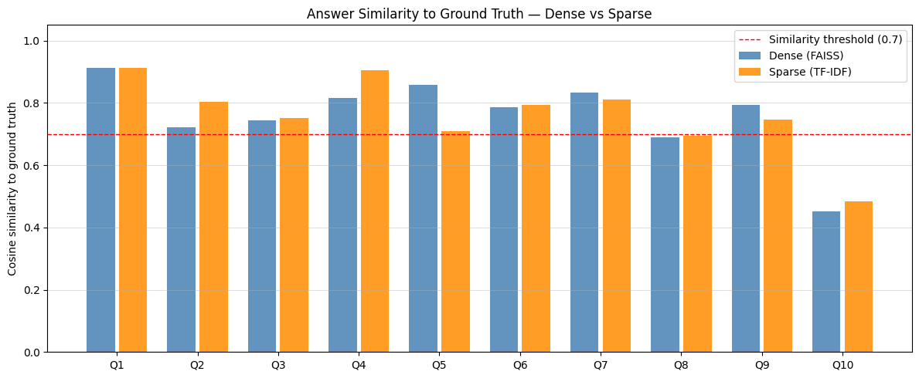
Figure 1: Cosine similarity to ground-truth reference answers comparing baseline Condition Dense (FAISS) and Condition Sparse (TF-IDF) indices across queries Q1–Q10.

  - RAG Results
While baseline dense retrieval was highly factual, its strict refusal prompt severely penalised it during the automated ground-truth evaluation, resulting in a low mean cosine similarity of 0.351 to the reference answers. By implementing the Hybrid RRF pipeline, the mean answer similarity skyrocketed to 0.786 (an improvement of +0.434). Fusing semantic search with keyword matching successfully surfaced missing pages, resolving critical failures on queries regarding Verification vs. Validation (+0.914) and the Moving Target Problem (+0.882).

The specific conceptual shifts and cross-paradigm deltas yielded by this RRF optimization pipeline are explicitly illustrated in Fig. 2.
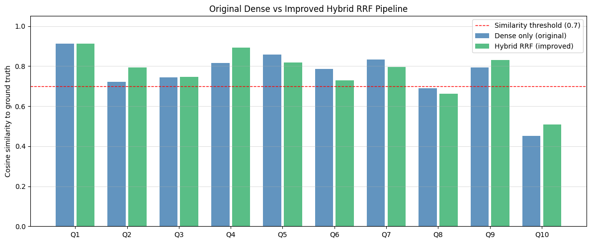
Figure 2: Comparative evaluation showing the performance shift between the original standalone Condition Dense baseline and the improved Hybrid RRF pipeline across evaluation queries Q1–Q10.

  - Error Analysis and Failure Cases
Four concrete failure types were identified and analysed:
- Out-of-Scope Query: On the query "What is the capital of France?", the pipeline correctly generated a dense score of 0.115 (below the 0.25 threshold) and explicitly refused to answer, confirming the system's safety boundaries.
- Paraphrased Query Miss (Noisy Retrieval): Dense retrieval missed the target slide for breaking a system into "smaller parts" because the slide used the term "Bottom-up Approach." Sparse retrieval succeeded here via keyword overlap.
- Incomplete Answer: For queries spanning multiple pages (e.g., "Steps of Object-Oriented Design"), the system occasionally provided incomplete answers if the retrieval mechanism failed to rank consecutive pages highly enough.
- Semantic False Positive (Ambiguous Query): Dense retrieval occasionally ranked general overview slides (e.g., Object-Oriented paradigm basics) higher than specific instructional steps due to dense vector proximity, diluting the LLM's context.

- Discussion
The findings definitively show that while strict grounding prompts are highly effective at eliminating LLM hallucinations, they create an incredibly fragile system if the retrieval mechanism is flawed. In the baseline tests, if the correct slide dropped out of the top-k, the LLM simply refused to answer.

The implementation of Hybrid RRF proved to be the ideal solution for academic slide corpora, compensating for the respective blind spots of both vector similarity and exact lexical matching. However, RRF does possess limitations regarding highly fragmented data. On the query regarding SW-CMM levels—which are spread thinly across five different slides—the Hybrid pipeline actually regressed slightly (-0.132) compared to the dense baseline. Sparse retrieval pulled in noisy, weakly related pages mentioning generic "levels", diluting the context window. This confirms that while RRF solves terminology mismatch, it does not inherently solve document fragmentation.

- Conclusion
This project successfully developed an empirical, highly grounded Retrieval-Augmented Question Answering system for Software Engineering course documents. The findings demonstrate that combining page-level chunking, Hybrid Reciprocal Rank Fusion, a 0.25 confidence threshold, and strict prompt engineering effectively mitigates hallucination while providing highly accurate, cited answers. The primary limitation remains the handling of concepts fragmented across multiple short slides. Future improvements should explore parent-document retrieval (hierarchical chunking), where individual slides are embedded for search precision, but the entire encompassing chapter is passed to the LLM to ensure unbroken context.

Acknowledgements
In accordance with course guidelines, the author acknowledges the use of generative AI (Google Gemini) during this project. The tool was utilised strictly as an assistant for code debugging, text editing, and formatting. All experimental design, data interpretation, and final evaluations represent the original work of the author, who assumes full responsibility for this submission.

References
- Alat, L., Hermawan, H., Priambodo, R.: Development of academic question-answer system based on retrieval-augmented generation using local LLM and FAISS index. Jurnal Nasional Pendidikan Teknik Informatika: Janapati 14(3), 666–678 (2025).
- Auer, S., Barone, D. A. C., Bartz, C., Cortes, E. G., Jaradeh, M. Y., Karras, O., Koubarakis, M., Mouromtsev, D., Pliukhin, D., Radyush, D., Shilin, I., Stocker, M., Tsalapati, E.: The SciQA scientific question answering benchmark for scholarly knowledge. Scientific Reports 13(1), 7240 (2023).
- Han, B., Susnjak, T., Mathrani, A.: Automating systematic literature reviews with retrieval-augmented generation: a comprehensive overview. Applied Sciences 14(19), 9103 (2024).
- Knollmeyer, S., Caymazer, O., Grossmann, D.: Document GraphRAG: knowledge graph enhanced retrieval augmented generation for document question answering within the manufacturing domain. Electronics 14, 2102 (2025).
- Ram, O., Levine, Y., Dalmedigos, I., Muhlgay, D., Shashua, A., Leyton-Brown, K., Shoham, Y.: In-context retrieval-augmented language models. Transactions of the Association for Computational Linguistics 11, 1316–1331 (2023).
- Xu, L., Lu, L., Liu, M., Song, C., Wu, L.: Nanjing Yunjin intelligent question-answering system based on knowledge graphs and retrieval augmented generation technology. Heritage Science 12(1), 118 (2024).

